Steps to create an Oracle linked server
*All steps were performed on a SQL Server 2005 64 bit instance(with Service Pack 3) and connecting to an Oracle 10g database. The Operating System is Windows Server 2008 64 bit.

For this exercise, you will need remote access to the server where Oracle is installed as well as the username and password you’ll use to connect to the Oracle instance.

- Downloaded the Oracle 11g 64 bit client for the Oracle Support site. As of this writing, only 11g Release 1 is available for 64 bit environments.
http://www.oracle.com/technology/software/products/database/index.html - Link to Oracle Database downloads site.
http://www.oracle.com/technology/software/products/database/oracle11g/111070_win64_2008soft.html - Link to the specific software pieces for 11g.
Download the Database 11g Release 1 Client (11.1.0.7.0)
- Upon completing the download, unzip the file to its default location which should be 11107_w2k8_x64_production_client. Open the client folder within and run the Setup.exe.
- On the first Installer screen, click Next.
- For the Installation Type, choose Custom and click Next.
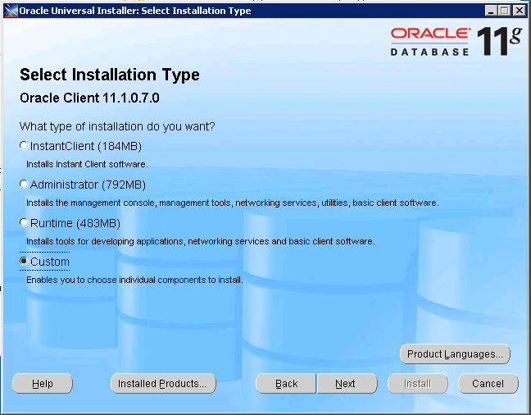
- You can change the installation directories if you choose, but of the purposes of this document, the defaults are left in place.
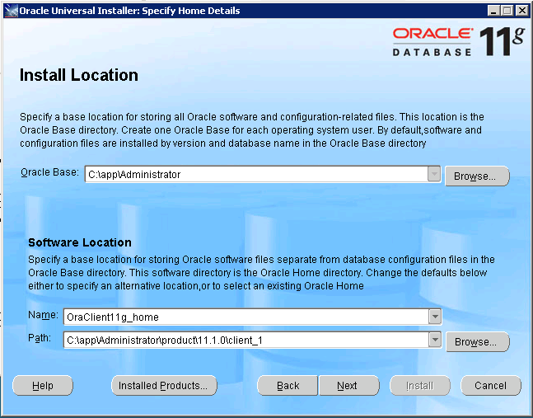
- The installation will go through some system checks. Once everything has been verified, click Next.
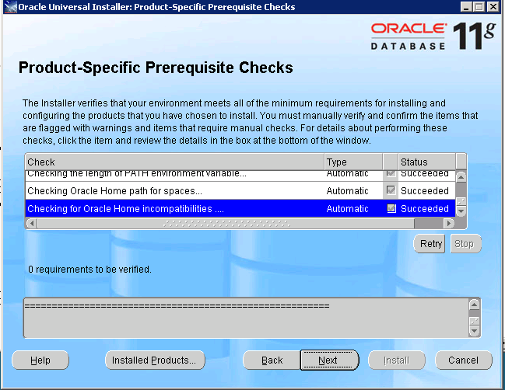
- The Oracle Client is selected by default. Scroll down the page and choose to install the Oracle Windows Interfaces. The options selected will be fine. Once you’ve selected the options, click Next.
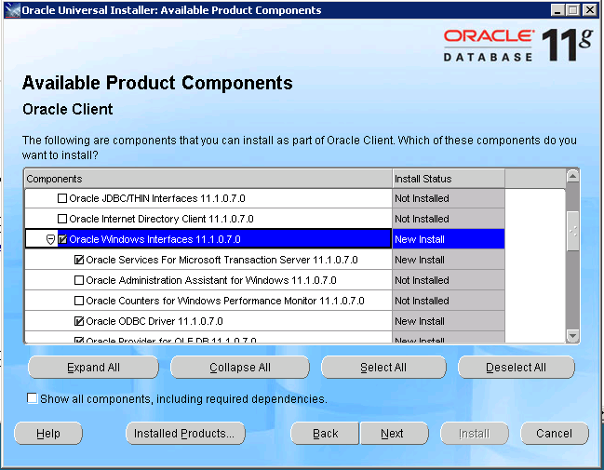
- You’ll be prompted for a port for the Microsoft Transaction Server. The default is 2030 and this is fine. Click Next.
- You’ll receive a summary page. Click Install to proceed.
- Once the install is complete, you can click the Exit button.
- Restart your SQL Server Services before attempting to connect the Oracle server.
- Next, you’ll need to connect to the server where the Oracle database resides via remote desktop or other method. Search for the TNSNames.ora file. You’ll probably find many files in various folders. The one you’re looking for should reside in the oracle\versionnumber\NETWORK\ADMIN folder.
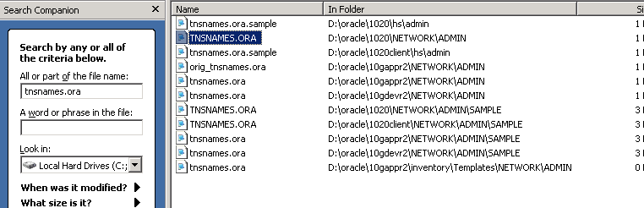
- Open the TNSNames.ORA file with notepad. Look for a connection string with the protocol of TCP.
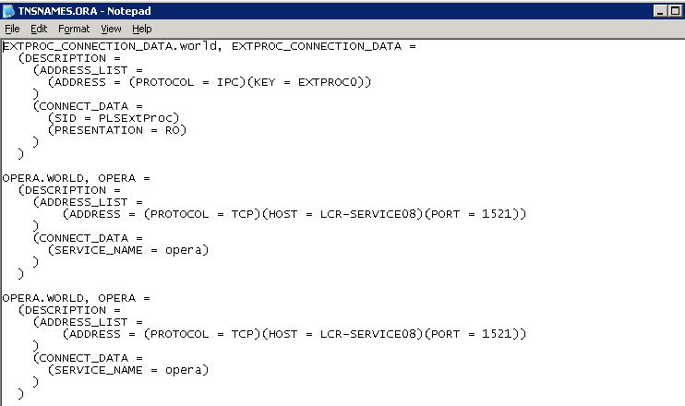
Take note of the values for host, port and service name. They’ll be important in the configuration.
- Back on your SQL Server, open SQL Server Management Studio. Connect to your local instance and expand Server Objects. Expand the Linked Servers folder and then Providers. Verify first that OraOLEDB.Oracle is listed.
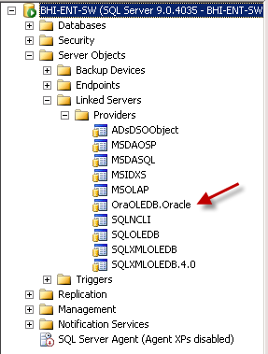
- Double click the Oracle provider to open the properties. Click the check box for Allow Inprocess. Then click OK to save.
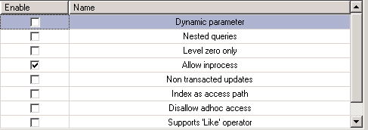
- Open a new Query window and execute the following:
EXEC sp_addLinkedServer 'NAME','Oracle','OraOLEDB.Oracle','HOST:PORT/SERVICE'
Replace the NAME field with the name you wish to identify this linked server as. The next two fields remain unchanged. Fill in the value for the last field with the Host, port and service you identified in the TNSNAMES.ORA file.
- Right mouse click on the Linked Servers folder in Object Explorer and choose Refresh to see your newly created item.
- Right mouse click on your linked server and choose Properties. Go to the Security page. At the bottom of the screen, choose Be made using this security context.
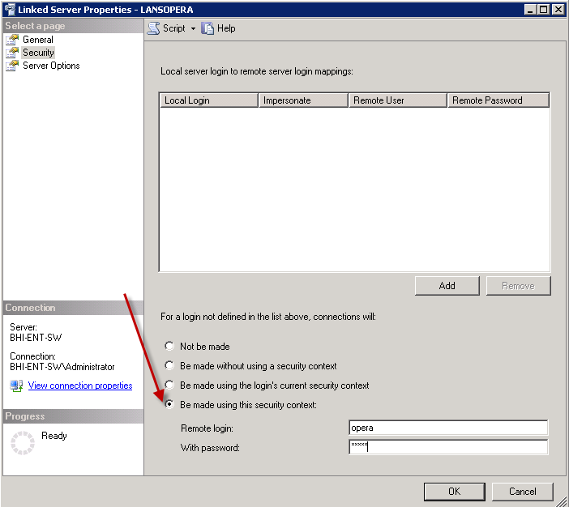
Fill in the Remote login and password with the credentials for the Oracle instance and click OK.
- Right mouse click your linked server again and choose Test Connection. If it is configured correctly, you’ll receive the following.
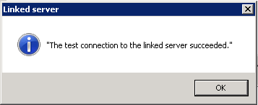
- Run the following statement in a query window:
exec sp_tables_ex 'LinkedServer'
Replace LinkedServer with the name you gave your linked server.
- If all is configured correctly, you should have a complete listing of all tables from the Oracle Instance.
- To query against one of those tables, use the following syntax
SELECT * FROM OPENQUERY(‘SELECT * FROM OracleTableName’)
This is an extremely generic statement, but if you get results, you’ll know that your linked server is configured properly.

